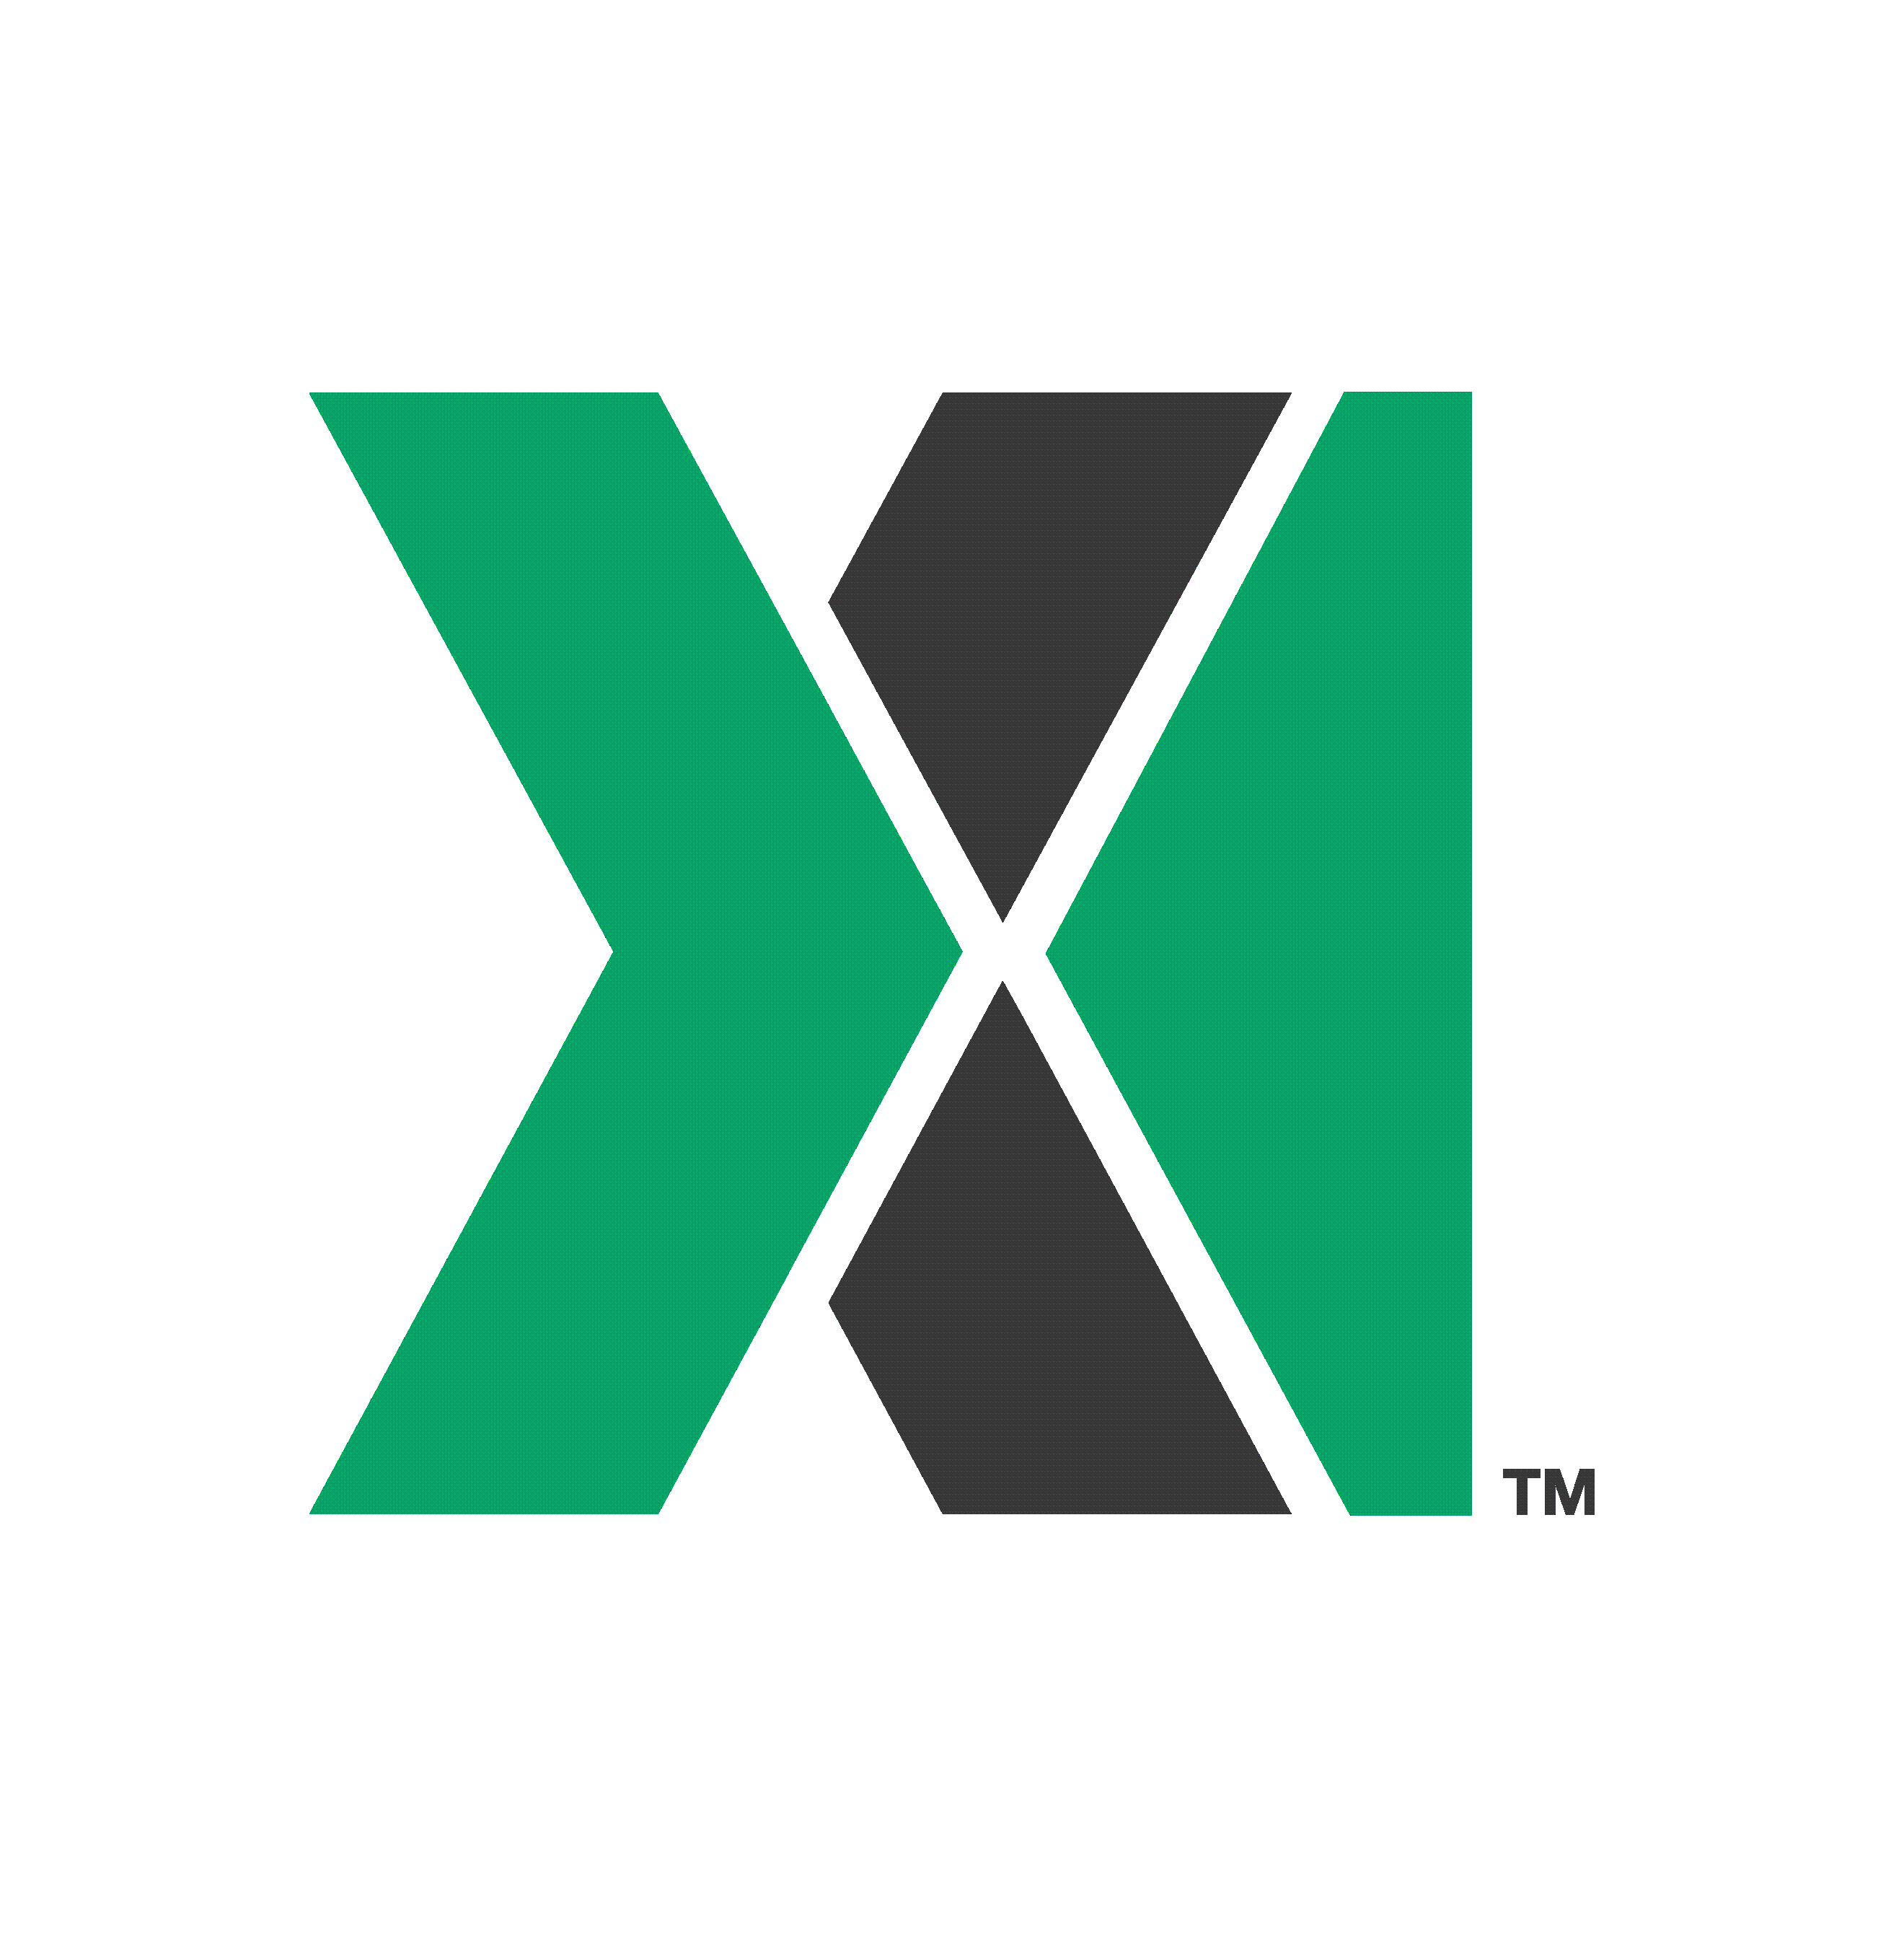

UNITED STATES
SECURITIES AND EXCHANGE COMMISSION

Washington, D.C. 20549

FORM 6-K

REPORT OF FOREIGN PRIVATE ISSUER PURSUANT TO RULE 13a-16 OR 15d-16 UNDER THE
SECURITIES EXCHANGE ACT OF 1934

For the month of July, 2026

001-41208
(Commission File Number)

NOVONIX LIMITED
(Translation of registrant’s name into English)

Level 38
71 Eagle Street
Brisbane, QLD 4000 Australia
(Address of principal executive office)

Indicate by check mark whether the registrant files or will file annual reports under cover of Form 20-F or Form 40-F.
Form 20-F ☒ Form 40-F ☐

Indicate by check mark if the registrant is submitting the Form 6-K in paper as permitted by Regulation S-T Rule 101(b)(1): ☐

Indicate by check mark if the registrant is submitting the Form 6-K in paper as permitted by Regulation S-T Rule 101(b)(7): ☐

EXHIBIT INDEX

Exhibit No. |  | Description
Exhibit 99.1 |  | ASX Announcement (Share Purchase Plan - Updated Timetable) dated July 10, 2026

SIGNATURES

Pursuant to the requirements of the Securities Exchange Act of 1934, the registrant has duly caused this report to be signed on its behalf by the undersigned hereunto duly authorized.

NOVONIX LIMITED
By: |  | /s/ Mike O'Kronley
 |  | Mike O'Kronley
 |  | Chief Executive Officer

Date: July 10, 2026

EXHIBIT 99.1


Asx Announcement
(ASX: NVX)
NOT FOR RELEASE TO US WIRE SERVICES OR DISTRIBUTION IN THE UNITED STATES

Share Purchase Plan – Updated Timetable
BRISBANE, Australia, July 10, 2026 - NOVONIX Limited (NASDAQ: NVX, ASX: NVX) (“NOVONIX” or “the Company”) a leading battery materials and technology company, provides an update in relation to the Share Purchase Plan ("SPP") announced on 17 June 2026.
Following receipt of the waivers sought by the Company from ASX Listing Rules 7.1 and 10.11 as announced on 6 July 2026,1 the Company advises that it has revised the SPP timetable and will bring forward the SPP Closing Date. The SPP will now close at 5:00pm AEST on Friday, 17 July 2026 ("Revised Closing Date"), instead of the previously announced closing date of 14 August 2026.
You must ensure that your application and payment are received (in cleared funds) by 5:00pm (Sydney time) on the Revised Closing Date. The Company advises that any further applications or payments under the SPP received after the Revised Closing Date will not be accepted, and the relevant application monies will be returned in full to the applicant (without interest), as soon as practicable after the Allotment Date.

The revised indicative timetable is set out below:

Event | Date (and time if relevant)
Record date for the SPP | 7:00pm on 16 June 2026
Opening Date and date that the SPP Booklet is made available | 10:00am on 22 June 2026
Revised Closing Date | 5:00pm on 17 July 2026
SPP results announcement | On or about 20 July 2026
Allotment Date | On or about 22 July 2026
Commencement of trading of Shares | On or about 23 July 2026
Note: This timetable is indicative only and subject to change. All dates and times are Sydney time. The commencement of trading and quotation of SPP Shares is subject to confirmation from ASX. Subject to

1 See ASX Announcement dated 6 July 2026 for further detail regarding the waivers granted by ASX, including the conditions on which the waivers were granted and the Company's reasons for seeking the waivers in relation to the SPP.

ACN 157 690 830, 1029 West 19th Street; Chattanooga, TN 37408; USA | novonixgroup.com

EXHIBIT 99.1

the requirements of the Corporations Act, the ASX Listing Rules and other applicable rules, NOVONIX reserves the right to amend this timetable at any time at its absolute and sole discretion, including shortening or extending the period for the SPP or accepting late Applications, either generally or in particular cases, without notice.
This announcement has been authorised for release by Admiral Robert Natter, Chairman.
About NOVONIX
NOVONIX is building a resilient North American battery materials supply chain to reduce risk and support U.S. energy independence. Headquartered in Chattanooga, Tennessee, the company produces high-performance synthetic graphite anode materials for lithium-ion batteries, serving energy storage, electric vehicles, and industrial markets. Through proprietary technologies and expanding manufacturing capacity, NOVONIX is scaling critical battery materials to meet growing global demand.
To learn more, visit us at www.novonixgroup.com or on LinkedIn and X.
For NOVONIX Limited
Investors: ir@novonixgroup.com
Media: media@novonixgroup.com

ACN 157 690 830, 1029 West 19th Street; Chattanooga, TN 37408; USA | novonixgroup.com

